2020年苏州中考英语综合测试卷
(满分:100分)
第一部分单项填空(共10小题;每小题1分，满分10分)
请认真阅读下面各题，从题中所给的A、B、C、D四个选项中，选出最佳选项。
1. — Mary, have you seen ________ film Avengers 4 recently?
— Yes, of course. I can't think of ________ more exciting one than that.
A. an; a B. the; an C. the; a D. a;the
2. — What is your key to success?
— I believe that nothing difficult will be ________ if I put my heart into it.
A. by the way B. in my way C. on the way D. in this way
3. — Why are you looking for Mary in a hurry, John?
— The boss is wondering where she ________ and how long she________ there.
A. has been; has been B. has gone; has gone
C. has been; has gone D. has gone; has been
4. — The volunteers really provided the athletes with support.
— Exactly. ________ great success they helped make the event!
A. What B. What a C. How D. How the
5. — I'll not be Jack's friend any more.
— Don't be angry. He's just so ________， but in fact he's good to us, you know.
A. helpful B. direct C. polite D. brave
6. — I ________ reading English every morning.
— Yes, now English ________ the most useful communication tool in England and some other countries.
A. am used to; is used by B. used to; is used as
C. used to; is used by D. am used to; is used as
7. — ________ did you do with old books?
— I sent them to children in poor areas.
A. How B. Where C. What D. Why
8. — I hear local people are trying to prevent some businesses building factories here.
— Yes. They say the place will be polluted if some factories ________ in the future.
A. will build B. will be built
C. is built D. are built
9. — Andy wins the first place!
— Really? Sounds ________ to believe.
A. too good B. good enough C. so good D. quite good
10. — All the people of Suzhou need to work together to make our city more beautiful.
— That's it. ________.
A. Practice makes perfect
B. Many hands make light work
C. When in Rome, do as the Romans do
D. A friend in need is a friend indeed
第二部分完形填空(共10小题;每小题1分，满分10分)
请认真阅读下面短文，从短文后各题所给的A、B、C、D四个选项中，选出最佳选项。
I sat down to read under an old tree in the park. I felt my life was __11__， for my whole world was dark. A young boy ran up to me, out of breath. He stood right before me with his head down and said, “Look what I've found!” In his hand was a flower, and what a poor sight! The flower was dry and __12__. I gave him a small smile and then turned my eyes away so that he could take his dry flower and go off to play.
__13__， he sat next to my side and put the flower to his __14__ and said in surprise, “It smells sweet and it's beautiful, too. That's __15__ I picked it. Here, it's for you.” The flower before me was dead. But I knew I must accept it, or he might never leave. So I accepted the flower, and replied, “This is just what I __16__.” Just then, for the first time I noticed that the boy could not see, because he was blind.
Tears came down my face as I __17__ him for picking the best one. “You're welcome，” he smiled and then ran off to __18__. I sat there and wanted to know how he was able to be so happy. Through the eyes of a blind child, __19__ I could see the problem was not with the world, and that the problem was me. And for all those years I myself had been blind. I decided to see the beauty in life, and __20__ every second of my life.
11. A. hopeless B. colourful C. simple D. wonderful
12. A. fresh B. dead C. alive D. old
13. A. So B. Or C. However D. And
14. A. nose B. head C. ear D. eyes
15. A. how B. when C. why D. where
16. A. want B. dislike C. admire D. have
17. A. looked B. thanked C. paid D. hated
18. A. sleep B. study C. play D. dance
19. A. at most B. at times C. at first D. at last
20. A. waste B. forget C. lose D. enjoy
第三部分阅读理解(共12小题;每小题2分，满分24分)
请认真阅读下面短文，从短文后各题所给的A、B、C、D四个选项中，选出最佳选项。
A
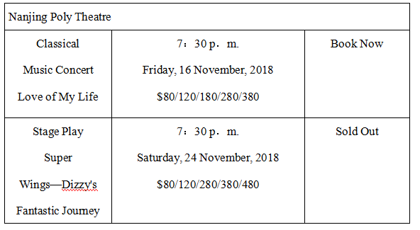
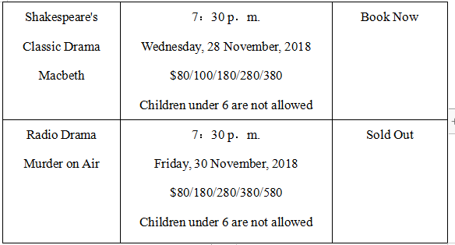
21. Mr Smith is interested in Shakespeare, so he can watch ________in Poly Theatre.
A. Murder on Air B. Macbeth
C. Love of My Life D. Super Wings—Dizzy's Fantastic Journey
22. Mr and Mrs Smith want to watch Love of My Life. They should pay at least ________.
A. $160 B.$ 180
C. $240 D. $360
23. Which of the following is TRUE?
A. You can watch the stage play on Sunday.
B. You can buy the ticket for Murder on Air.
C. You can watch Love of My Life if you love music.
D. You can watch the radio drama with your 5yearold son.
B
Ron Roy grew up in the 1950s. He lived in a small town in Connecticut. He went to a tiny school. After school he played in the woods behind his house. On the weekend he went to the movie theatre with his friends. When Ron Roy was nine years old, he was given a book for his birthday. The book told a magical story. It made him want to read more and write stories of his own.
Ron Roy kept reading as he went through school. He loved to read. It didn't matter what the story was. He loved them all. This love for books led him to study English literature in college. A love for children made him want to be a teacher. After several years in school, Ron Roy started teaching. Books and stories were all around him. One day, he knew—he wanted to write books too.
So, Ron Roy got to work. Every evening after he came home from school he wrote. As soon as his story was finished, he started another one. When each story finished, he put it in the mail. He sent every story to a book publisher(出版商). Soon, the replies started coming back to him. Each one was the same. “No.” “Sorry.” “We're not interested.” No one wanted to print his stories. Still, Ron Roy did not give up. He kept writing. Four years later, nothing had changed ...Until one day, it did. One day, a letter came in the mail that said, “We would love to publish your book.” Ron Roy was over the moon. All of his hard work had finally paid off!
24. What did Ron Roy do on the weekend when he was a boy?
A. He read magical stories.
B. He went to the library.
C. He played in the woods.
D. He went to the movies.
25. How long did it take before his first book was published?
A. Four weeks. B. Four months.
C. Four years. D. Fourteen years.
26. What can we learn from the story?
A. Love keeps us busy all the time.
B. Helping those in need makes one feel good.
C. Believe in yourself and you can succeed.
D. A book publisher refused to print the stories.
C
For the first time in history, the International Olympic Committee(IOC) has decided two host cities at the same time. Paris will host the Olympic Games in 2024 and Los Angeles in 2028.
“This is a winwinwin situation for Paris, Los Angeles and the IOC，” said IOC President Thomas Bach. “These are two great cities from two great countries with a great Olympic history.”
Both cities are excited in bringing home the Games. It has returned to the USA for the first time since the 1996 Atlanta Olympics.
But Paris has waited for too long. As the city that has hosted two Olympics before, it will host the event 100 years after its last Games. It also means Paris will become the second city to hold three Summer Olympic Games after London.
However, the reason for the decision is that there were no other competitors for either the 2024 or 2028 Games. Before the last decision, three of the five cities gave up bidding__for the 2024 Olympics because of worries over costs. They were Hamburg, Rome and Budapest. But it seemed Paris and Los Angeles had less trouble with costs.
27. When did Paris host its latest Olympic Games?
A. In 1896. B. In 1918.
C. In 1924. D. In 1996.
28. What does the underlined phrase “bidding for” mean?
A. Applying for. B. Holding.
C. Voting for. D. Joining in.
29. Which of the following cities ever held at least two Summer
Olympic Games according to the passage?
① Paris ② Los Angeles ③ Hamburg ④ Rome
⑤ Budapest ⑥ London
A. ①② B. ①②⑥ C. ③④⑤ D. ①⑥
D
Memory is often the source of our greatest joys as well as our deepest regrets. I cherish every memory I have of my Mom, but at the same time I regret no longer being able to create new ones with her. My Mom left this world when I was only 25 years old. I never got a chance to say “Thank You” to her for all of them. All I can do now is share these memories with you.
Mom, I remember when you spent hours walking with me searching for my dog Duke when he ran away. You never let me lose hope. I remember too you putting him in my bed after he finally found his own way home.
Mom, I remember how you never complained when you took me, my wife, and our newborn baby son into your home when I was struggling financially the first year of my marriage. You showed me what it took to love and raise a child.
Mom, I remember all the lessons you taught me about patience, humor, and courage when you faced your long battle with cancer. It may have finally taken your body, but it never got your spirit. I also remember how you always ended our phone calls those last years of your life with those three words that live on inside of me today: “I Love You!”
Mom, I would give everything I have for just one more hug from you. You gave me so much love. You helped make my heart and soul what they are today. I love you and will continue to love you more every single day of my life.
30. Why does the author write the passage?
A. Because he wants to share his memories.
B. Because he wants his mother to read it.
C. Because his mother made him do this.
D. Because he is a writer.
31. Which of the following is NOT true?
A. The author likes his mother very much.
B. Maybe the author's mother died of cancer.
C. Duke is a name of a person.
D. Mom taught the author lots of things.
32. What's the best title for the passage?
A. Never lose your heart
B. Memories of my mom
C. All happy families are the same
D. Source of our greatest joys
第四部分信息还原(共5小题;每小题1分，满分5分)
根据对话内容，从对话后的选项中选出能填入空白处的最佳选项。选项中有两项为多余选项。
Now people have more money than before, and they want to enjoy life. __33__ Listen! Some people are talking about their vacation plans.
“I love sports. I'm going bike riding with my family on vacation. __34__ That's really great，” said Mrs Lee. Mr Zhao loves nature. He said, “I'm walking in the countryside or going hiking in the mountains. __35__” Miss Wang wants to be more beautiful. “I'm planning to go shopping. __36__” Zhang Yishan is a movie actor. He just finished his last movie. __37__ He said, “I like going sightseeing. I am staying in Canada for a month.”
A relaxing vacation! I can't wait!
A. I want to buy lots of beautiful clothes.
B. Now he really wants to get some rest.
C. Many people can come to buy clothes in my shop.
D. We can exercise and enjoy lots of interesting places.
E. But a lot of people like travelling in the countryside.
F. I hope the beauty of nature can help me to forget all of my problems.
G. So people have different ideas about how to enjoy their vacations.
33. ________ 34. ________ 35. ________ 36. ________ 37. ________
第五部分词汇检测(共10小题;每小题1分，满分10分)
根据下列句子及所给汉语注释或通过上下文，写出空缺处各单词的正确形式。每空只写一词。
38. We all ________(期待) him to come soon so that we could finish all the work earlier.
39. Luckily, Daniel was chosen to be one of the ____________(秘书) of the Student Union.
40. There is a ________(巨大的) stone on the road. You must be careful when driving.
41. I tried to pull one hand free and finally ________(设法) to break the ropes.
42. When we start a conversation in England, please be careful to_______(避免) subjects like age, weight or money.
43. The little boy will travel ________(到国外) to learn more about art.
44. — When can you carry out your plan?
— I'm not sure. It's still under ____________(讨论).
45. — How many days is this museum open?
— It is open six days a week. It means that it is open every day ________ Monday.
46. — Why do you hate living in big cities?
— Because the air is very dirty. Air __________ is a serious problem.
47. — I'm going to do some exercise and try to lose some weight.
— Are you ________? I never see you get out of your chair!
第六部分 句子翻译(共5小题;每小题3分，满分15分)
将下列句子译成英语，并将所译句子写在横线上。
48.你叔叔离开中国多久了?
________________________________________________________________
49.格林先生下个月将被邀请做一个关于英语阅读的演讲。
________________________________________________________________
50.他在公共场所吸烟是不对的。
________________________________________________________________
51.汤姆年龄不够大，不能在家照顾自己。
________________________________________________________________
52.学生们通常用电脑搜寻信息。
________________________________________________________________
第七部分阅读表达(共3小题;53题1分，54题2分，55题3分，满分6分)
请认真阅读下面短文，用英语回答短文后的问题，并将答案写在横线上。
Have you ever been irritated(激怒) by someone shouting at his mobile phone in a public place?
We've all lost temper at least once at the sound of a person loudly communicating with someone on a mobile phone.
Recently, Dr Adam Rutherford has been answering questions: “I have no interest in hearing about other people's private lives.” “The conversation would have seemed to worry older generations. I think they would have considered it rude to talk loudly in public.”
Many people seem to do it without realizing why, but is there a scientific reason for their loudness?
The answer begins by looking at one of the telephone designs called “sidetone”—a feature whereby a caller could hear his own voice in the phone's speaker when talking.
This guarantees the user that they can be heard, leaving no reason to raise one's voice. But the problem with mobiles is that they are mobile, and a fixed volume of “sidetone” isn't always effective where background noise is very loud.
Plus, this is our natural tendency(倾向) to raise our voice to match the noise levels around us. We tend to try and match the loudest sound we can hear.
It is worth pointing out, however, that this would not be the first time that our use of mobile phones has challenged the idea of good manners. When phones were firstly invented, they raised all kinds of questions. Should one have a phone conversation when undressed? Was it proper to stand up when speaking to a woman on the phone?
It seems mobile phones, then, are a technology that may always form new etiquette issues(礼仪问题).
53. When do we easily lose temper?
_______________________________________________________________
54. Where isn't the fixed volume of “sidetone” always effective?
_______________________________________________________________
55. Do you want to have a telephone called “sidetone”? Why or why not?
_______________________________________________________________
_______________________________________________________________
第八部分书面表达(共1题;满分20分)
假如你是李华，你的美国好友Daniel想了解你的数学考试情况、暑期安排和对新学校生活的期待。请根据Daniel电子邮件的内容，用英语给他写一封回信。
From：Daniel@wde.ac.us
Hi，
How are you?I know you're busy with your English exam right now.How is it?Anyway，it'll be all over soon.What are you going to do during the summer vacation?What do you look forward to about your new school life?Please e-mail me and let me know.
Yours,
Daniel
要求：1. 文中不得出现你的真实姓名和学校名称;
2. 语言通顺、意思连贯、条理清楚、书写规范;
3. 词数80左右，邮件的开头与结尾已经给出，不计入总词数。
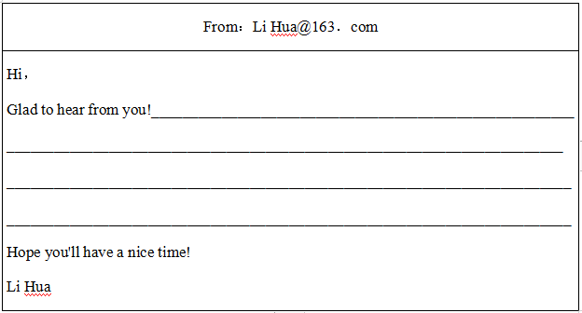
参考答案
第一部分1-5 CBDAB 6-10 DCDAB
第二部分11-15 ABCAC 16-20 ABCDD
第三部分21-23 BAC 24-26 DCC 27-29 CAB 30-32 BCB
第四部分33-37 GDFAB
第五部分38.expect 39.secretaries 40.huge 41.managed 42.avoid 43.abroad 44.discussion 45.except 46.pollution 47.kidding
第六部分48.How long has your uncle been away from China?
49. Mr Green will be invited to give a lecture about English reading next month.
50. It’s not right for him to smoke in public places.
51. Tom isn’t old enough to look after himself at home.
52. The students usually use computers to search for information.
第七部分.53.When we hear a person loudly communicating with someone on a mobile phone.
54.In noisy places.
55.No, I don’t. Because it’s impolite and makes others angry.
第八部分
One possible version:
Glad to hear from you! I did well in English exam because English is my favourite subject. Anyway, I will be free after the exam. I will travel to Beijing with my parents. I also plan to work as a volunteer in my community. Besides, I will probably visit my grandparents in the countryside during the summer vacation. I am looking forward to my new school life. I hope my new school has many different kinds of clubs. I also believe I will make great progress if I try my best in my new school.
Hope you’ll have a nice time!
Li Hua

